**ESE – Computer Programming**

**Name**: Ayush Jain

**Sap ID**: 60004200132

**Div**: J1

**Branch**: Computer Science

**Date**: 24/09/2021

Q 5.] Write a program to check whether entered string is palindrome or not.

**Code:**

#include <stdio.h>

#include <string.h>

int main()

{

char s[1000];

int i,n,c=0;

printf("Enter the string : ");

gets(s);

n=strlen(s);

for(i=0;i<n/2;i++)

{

if(s[i]==s[n-i-1])

c++;

}

if(c==i)

printf("string is palindrome");

else

printf("string is not palindrome");

return 0;

}

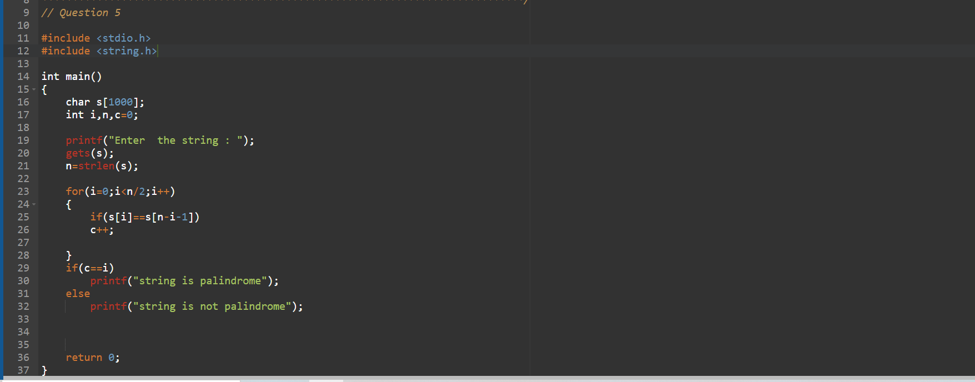

**Output**:

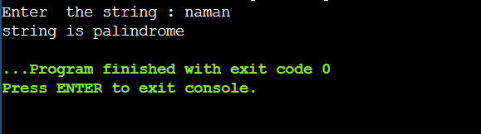

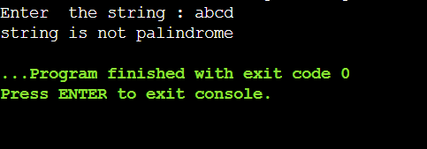

Q.6] Write a program to swap two numbers using call by value and call by reference.

**Code:**

#include <stdio.h>

void swapVal(int a, int b)

{

int temp;

temp = a;

a=b;

b=temp;

printf("Numbers after swapping by call by value function:\n a=%d and b =%d\n",a,b);

}

void swapRef(int*a,int*b)

{

int temp;

temp =*a;

*a=*b;

*b=temp;

printf("Numbers after swapping by call by reference function:\n a=%d and b=%d\n",*a,*b);

}

void main()

{

int a,b;

printf("Enter two Numbers:");

scanf("%d %d",&a,&b);

swapVal(a,b);

printf("After returning from swap by call by value function:\n a=%d and b=%d\n",a,b);

swapRef(&a,&b);

printf("After returning from swap by call by reference function:\n a=%d and b=%d\n",a,b);

}

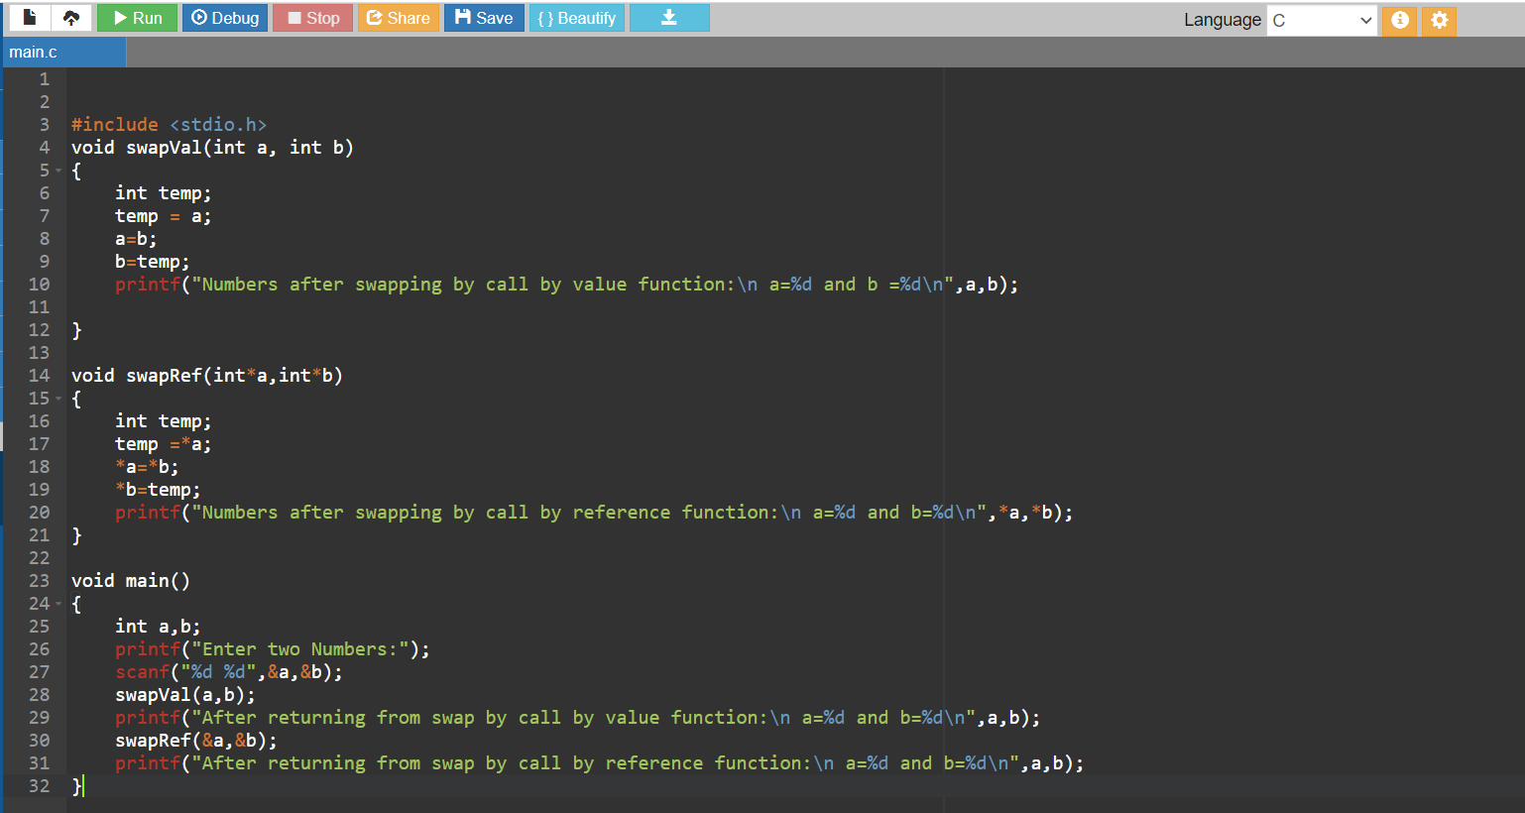

**Output**:

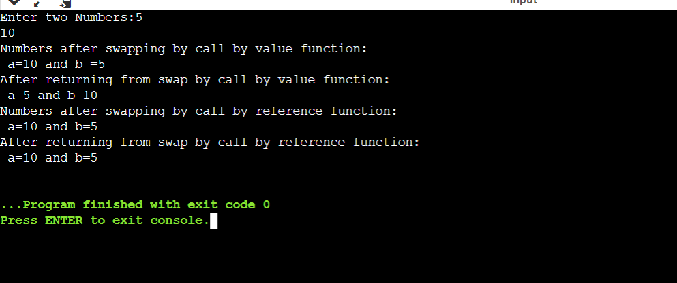

Q2 Write a program using for loop to print the pattern

**Code:**

#include <stdio.h>

int main()

{

int i, j;

char c = 'P';

for (i=0; i<6; i++)

{

c = 'P';

for (j=0; j<i; j++)

{

printf("%c", c);

c++;

}

printf("\n");

}

return 0;

}

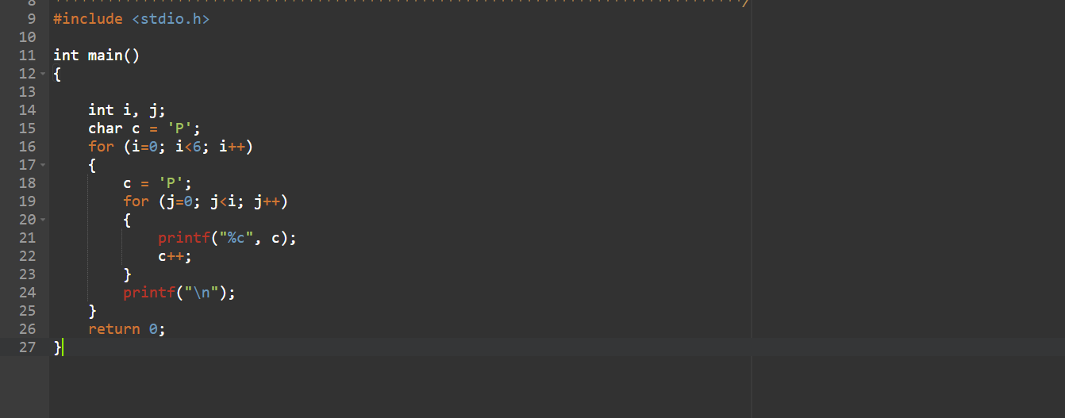

**Output**:

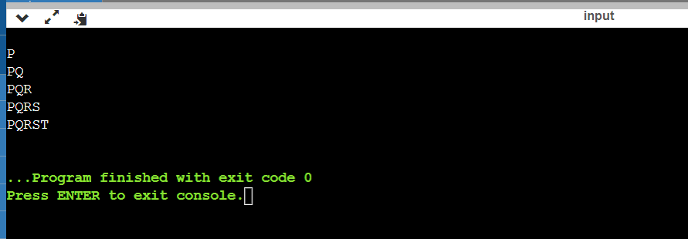

Q1] This program will read a character and check whether it is digit or vowel using switch case statement.

**Code:**

#include <stdio.h>

int main()

{

char input;

printf("Enter the character: ");

scanf("%c", &input);

switch(input)

{

case 'a':

case 'e':

case 'i':

case 'o':

case 'u':

case 'A':

case 'E':

case 'I':

case 'O':

case 'U':

printf("It is a vowel");

break;

case '1':

case '2':

case '3':

case '4':

case '5':

case '6':

case '7':

case '8':

case '9':

case '0':

printf("It is a digit");

break;

default:

printf("Invalid Input!");

}

return 0;

}

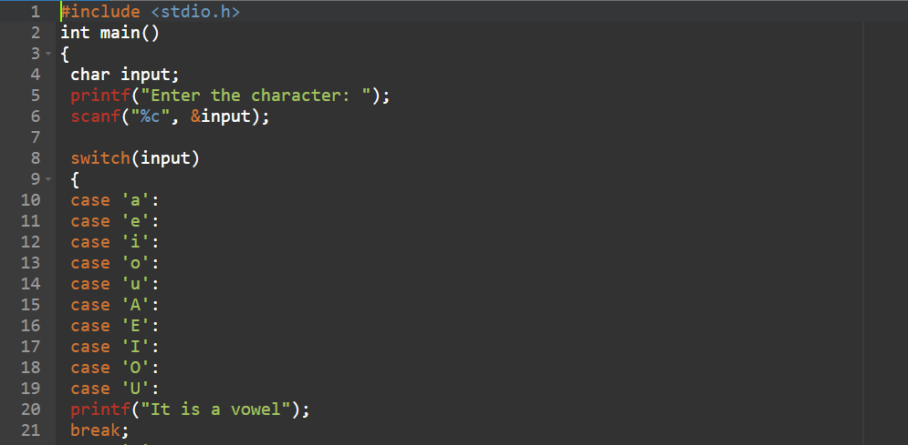

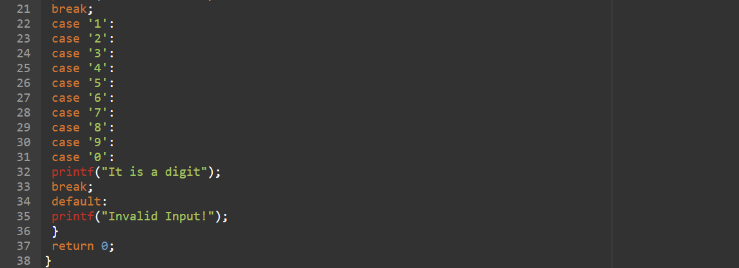

**Output**:

